
St Mary Magdalene C of E Primary School
Headteacher: Mrs S Pearson
Deputy Headteacher: Miss E Cave/Mrs R Turvey
Chair of Governors: Mrs K Fairbairn-Wint

SEND Information Report
St Mary Magdalene CE Primary School’s Mission Statement is:

“Broadening horizons with love, laughter and learning.”

At St Mary Magdalene C of E Primary School, we aspire to cultivate the gifts and talents of every child and equip them with the wisdom, knowledge and skills to live life in all its fullness: its joys and celebrations, its sorrows and struggles.

Our school’s approach to supporting pupils with SEND:
All children and young people are entitled to an appropriate education; one that is appropriate to their needs, promotes high standards and the fulfilment of potential. This should enable them to achieve their best, become confident individuals living fulfilling lives, and make a successful transition into the next phase of their lives.

We believe that every teacher is a teacher of every child, including those with special educational needs and pupils who may be disadvantaged.

The worth of each child compels us to strive to fulfil their God-given potential, with special consideration given to those who are disadvantaged. Therefore, we aim to:

- Develop the curriculum to extend the needs and fascinations of all children
- Build curiosity and excitement about the world we live in through rich first-hand experiences and visits
- Nurture the aspirations and hopes of all children so they can achieve highly
- Cultivate children’s wider interests through high quality extra-curricular opportunities
- Provide quality first teaching for all
- Ensure that all children make good or better progress
- Facilitate high quality training for staff to equip them with the skills to ensure that all children flourish

Responsibility for the coordination of SEN provision
- Head Teacher: Mrs Sarah Pearson
- SENDCo/ Inclusion Manager: Miss Amy Wain (SENDCo)
- Head of Governing Body: Mrs Rachel Watson

Contact details: office@stmarys.snmat.org.uk Telephone: 01623 464246

A number of other adults are deployed throughout school to provide support for pupils within the classroom. They work under the direction of class teachers, overseen by the school’s SENDCo. They also provide 1:1 support for pupils with more complex special educational needs. In addition to this, we use the services of a trained CASY (Counselling and Support for Young People) counsellor working in school with individual children or small groups.

Catering for different kinds of SEND:
A child has SEN if they have a learning difference or disability which calls for special educational provision to be made for them. A child has a learning difference or disability if they:

- have a significantly greater difficulty in learning than the majority of others of the same age; or

- have a disability which prevents or hinders them from making use of educational facilities provided for others of the same age in mainstream schools

We recognise and cater for the four broad areas of need, which are:

- Communication and Interaction
- Cognition and Learning
- Social, emotional and mental health difficulties
- Sensory and / or physical needs

DPE

The school recognises the importance of professional development for staff in relation to Special Educational Needs. Training is provided for all school staff as necessary, including teachers, TAs and midday supervisors. This may be whole school training or key members of staff attending training sessions and subsequently disseminating the information within school. SEND governors are invited to attend these meetings. Training opportunities are matched to school development priorities. Recent or ongoing training includes:
- Supporting SEND or vulnerable pupils (SFSS)
- Understanding the Behaviour Training (EPS)
- Developing a Language Rich Environment (S&L)
- Dyslexia Friendly Classroom training (C&L)
- Interoception Training (C&L)
- Emotion Coaching

Identifying and assessing pupils with SEND
Concerns that a child has a special educational need may be raised by class teachers, parents and pupils. Class teachers, supported by the senior leadership team, identify pupils making less than expected academic progress; this may include progress in other areas – for instance, social and emotional development. This can be characterised by progress which:

• is significantly slower than that of their peers starting from the same baseline
• fails to match or better the child’s previous rate of progress
• fails to close the attainment gap between the child and their peers

Any pupils who are falling significantly outside of the range of expected academic achievement will be closely monitored in order to gauge their level of learning and possible difficulties. The child’s class teacher will provide differentiated learning opportunities/ specific short-term interventions and assess their impact on progress. This will be recorded using the Cause for Concern form, and advice sought from the SENDCo.

Staff are trained to use a number of formal assessment within school to identify specific difficulties. Advice may also be sought from outside agencies with parental permission, if appropriate. For more detailed information, please see the diagram over the page, or St Mary’s SEND Policy

St Mary’s Graduated Approach:

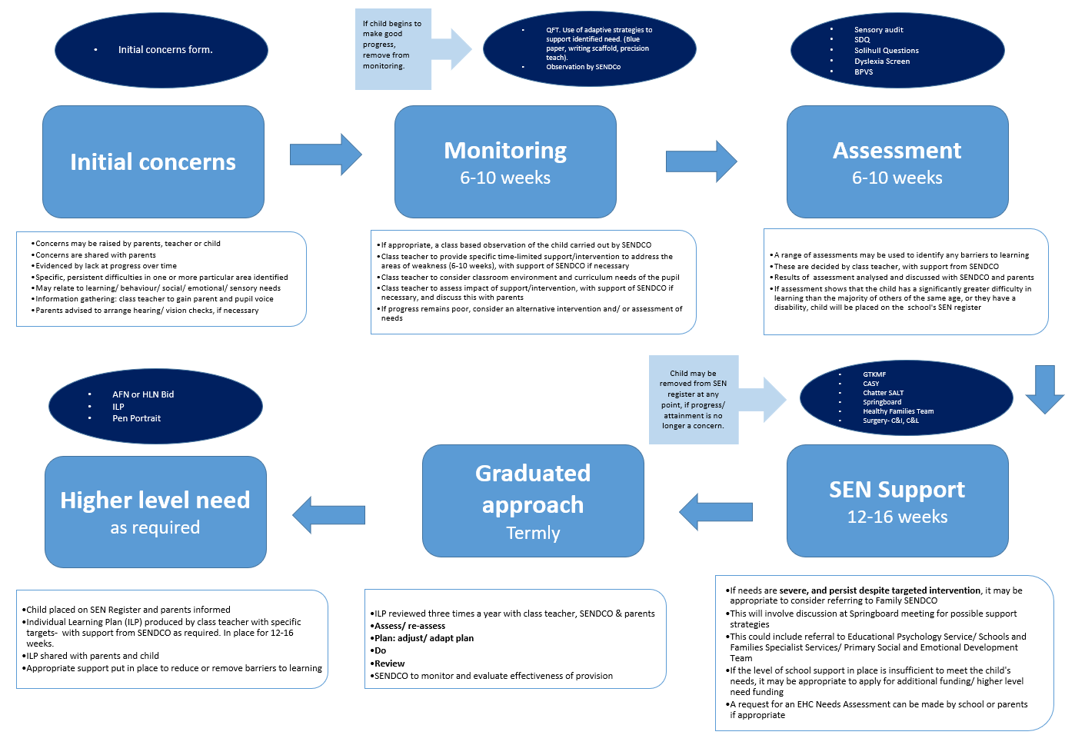

- Class teachers are responsible for the progress of all pupils in their class
- All pupils at St Mary’s, including those with special educational needs and disabilities, will receive ‘Quality First teaching’ (QFT) from the class teacher
- Class teachers will direct additional adults to support any pupils as necessary
- Pupils with SEND will receive targeted teaching aimed at their area(s) of difficulty
- A graduated response will be followed: assess, plan, do, review
- Advice from outside agencies will be sought if appropriate to provide support/ assessment/ interventions
- The curriculum and learning environment will be adapted as required for individual pupils
- Every effort will be made to ensure that pupils with special educational needs or disabilities will be included in the whole school life, including extra-curricular activities e.g. trips, clubs
- The strengths of pupils with SEND will be celebrated and built upon

For further detail regarding how we support pupils with special educational needs, please see also the following policies: SEND; Safeguarding; Behaviour; Anti-Bullying; Equality; Supporting Pupils with Medical Conditions; Accessibility Plan (available at http://www.stmarymagdaleneprimary.co.uk/policies/).

Consulting with parents and pupils
St Mary’s has an open door policy where parents are welcomed into school to speak to their child’s class teacher if they have any concerns. In addition to parent’s consultation evenings twice a year, parents of pupil on the SEN register will be invited to review their child’s Individual Learning Plan (ILP) three times a year. As part of this process, pupil views will also be gained.

The Local Offer
Support is available to parents through Nottinghamshire’s Local Offer. The SEND Local Offer is a resource which is designed to support children and young people with special educational needs and/or disabilities and their families. It describes the services and provision that are available both to those families in Nottinghamshire that have an Education, Health and Care Plan and those who do not have a plan, but still experience some form of special educational need.

The SEND Local Offer includes information about public services across education, health and social care, as well as those provided by the private, voluntary and community sectors.

www.nottinghamshire.sendlocaloffer.org.uk

Further support for parents and carers of children with special educational needs and disabilities is available through Nottinghamshire’s free, confidential Information, advice and support service, ‘Ask Us.’ This service provides impartial advice, information and support across education, health and social care issues. Children and young people with SEND can also use the service.

https://askusnotts.org.uk

Involving key stakeholders.
St Mary’s has positive working relationships with external support agencies, which are used to fully support our pupils with SEND and ensure inclusion.

The following support services are involved as required:
- Early Help Unit
- PSED Team/ NAP
- Educational Psychologist
- Specialist Teachers – Visually/ Hearing Impaired
- NHS Speech and Language Therapy
- Chatter Independent Speech and Language Therapy
- Schools and Families Support Services (Early Years, Communication and Interaction, Cognition and Learning)
- Physical Disability Support Service
- Community Paediatrician
- Healthy Families Team (including School Nursing Service)
- Primary Mental Health Team
- Child and Adolescent Mental Health Services
- Small Steps (for assessment and referrals)
- CASY

Funding for SEND
All pupils with SEND will be supported by Element 1 and 2 of St Mary’s budget, which equates to £6,000 per year. Some pupils with SEND may require additional funding (AFN). This additional funding may come from a budget which is devolved to and moderated by the Family of Schools (Sutton Community Academy and its feeder primary schools). For those with the most complex needs, additional funding is retained by the Local Authority. The Family SENCDO, Christine Turner, will refer individual applications to a multi-agency panel, which is administered by the Local Authority, who will determine whether the level and complexity of need meets the threshold for this Higher Level Need funding (HLN).

Transition support
Successful transition of children with SEND is a priority at St Mary’s. Our Foundation Stage team work closely with local childcare providers to ensure that we have as much information as possible about our youngest pupils when they join St Mary’s. In this way, we can begin to put the necessary support in place, as soon as possible. As pupils move from KS2 to KS3, Y6 teachers liaise with the secondary school SENDCo and Y7 colleagues to discuss the SEND pupils who will be transferred. Detailed information, including ILPs, are passed on to enable Secondary Schools to prepare for these pupils. Transition meetings are held at the end of every academic year between school staff and families of all pupils with additional needs to ensure that all parties are prepared for the next school year.

Supporting social and emotional development
We aim to establish well-being provision which raises all pupils’ self-esteem:

- Communicate a sense of importance; praising children for making the right choices
- Celebrate differences, promoting examples of individuals who have achieved despite their difficulties in learning
- Ensure successful experiences for all children
- Emphasising children’s responsibility through providing choices
- Ensure circle time/P4C is part of the curriculum
- Vary groups in class according to friendship and abilities
- Display and celebrate children’s outcomes
- Pastoral support for children with special educational needs, medical conditions and disabilities and mental ill health
- Provide space and time for spiritual growth

We understand that disruptive behaviour can be a possible manifestation of special educational, or mental health needs. When this is identified, specific interventions will be put in place to support the child with positive reinforcement strategies. Under these circumstances, we will work closely with parents to ensure a consistent approach between home and school and ensure clear communication.

Online Safety
At St Mary’s, we recognise the additional risks that pupils with SEND face online, e.g. through online bullying, grooming and radicalisation. All children regularly participate in e-safety lessons in school. We also have guest speakers such as the NSPCC who deliver assemblies and workshops for our pupils. Please see the Anti-Bullying and E-Safety Policy for more details.

Sexual violence and harassment
All staff receive weekly safeguarding updates, in addition to annual statutory safeguarding training. St Mary’s has a Designated Safeguarding Lead (DSL) – Miss Emily Cave, and two Deputy DSLs- Mrs Sarah Pearson, Miss Amy Wain. For further information, please see St Mary’s Safeguarding Policy (available on the school website).

Evaluating effectiveness
The effectiveness of SEND provision at St Mary’s is analysed as part of the school quality assurance cycle by the Head Teacher and Senior Leadership Team (SLT), which includes the SENDCo/ Inclusion Manager, and the school’s governing body.

The views of parents and pupils on how successful the provision has been in enabling them to attain their outcomes is discussed at ILP review meetings and gained through parent/ pupil voice surveys.

The progress of pupils with special educational needs is monitored termly through pupil progress meetings. We use a variety of indicators to measure the progress that children make, including teacher assessment, evidence in books, standardised assessments and progress against individual targets. Progress data will be shared with the Head Teacher, SLT and governing body, and will be judged by external moderators such as Ofsted.

Handling complaints
We welcome feedback from parents. There may be occasions when parents have concerns regarding the support their child is receiving. In the first instance, parents should speak directly to their child’s class teacher and/ or SENDCo. If the matter is still not resolved, parents have the right to make a formal written complaint to the school’s Chair of Governors. Please see the SNMAT Complaints Policy, available on the school’s website, for further information.

